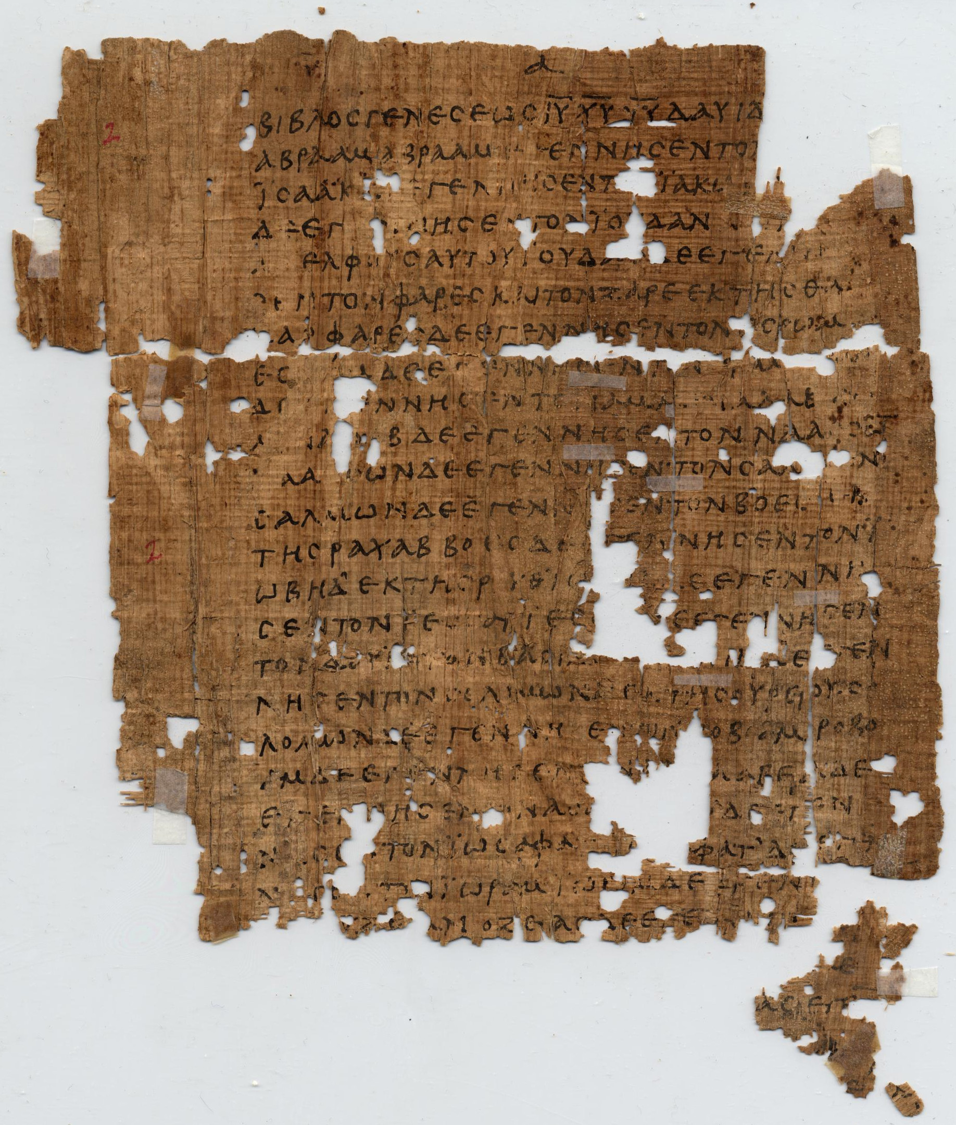
How To Become A Disciple Of Jesus Christ

Jesus’ Sermon on the Mount: Study 4
‘For Whom Do We live?’
(Matthew 6:1-8,16 - 18)

[Jesus said,] “Be careful not to practice your righteousness in front of others to be seen by them. If you do, you will have no reward from your Father in heaven.” (Matthew 6:1)

Jesus once told a story of two men who went into God’s temple to pray. One was a notorious sinner, the other was a very religious man. But the surprise ending to Jesus story is that, when both prayers were completed, it was the sinner who went home with God’s favour, not the religious man. The point of Jesus’ story is that it matters how, why and for whom we do our religious activities. (See Luke 18:9 – 14)

Throughout this section of his sermon, Jesus exhorts his disciples to live to honour God instead of trying to gain the praise of people. At times I’m sure many of us have caught ourselves worshipping or praying in a way that is more a performance for those around us than an interaction with God. So how do we practice our faith in a way that pleases God?

1. (Read Matthew 6:1 – 8, 16 – 18). Jesus teaches his disciples not to practice our righteousness in order to be seen by others. After reading these passages, how would you define these ‘righteous practices’ in your own words?

2. What might motivate or tempt us to do these things in order to be noticed by others?

3. In Matthew 6:16 Jesus says that those who do good things in order to gain people’s approval have already received (in that human praise) the only reward they’re going to get. Why will doing good for selfish gain mean forfeiting God’s approval?

4. In 6:2 – 4, Jesus warns his disciples not to make a show of giving to the needy? What might showy generosity look like today? How should we give to needy people?

5. The Bible teaches that public worship is a good and acceptable activity (e.g. Psalm 35:18). Therefore, what is the underlying principle in Jesus’ instruction, “6:6 But when you pray, go into your room, close the door and pray to your Father, who is unseen. Then your Father, who sees what is done in secret, will reward you.”?

6. In 6:16 – 18, Jesus warns his disciples not to draw attention to their fasting. Give a positive example of going without something for a time as a way of worshipping God or for our spiritual good?

7. Twice in this section (6:6 & 18), Jesus points to God’s example of giving to us secretly (while remaining unseen). Give some examples of ways in which God gives gifts to people simply because he loves us, without drawing attention to himself.

8. Give one example of how Jesus’ teaching has challenged you to change your inner attitude or outward practices toward worship, prayer or doing good for others.

