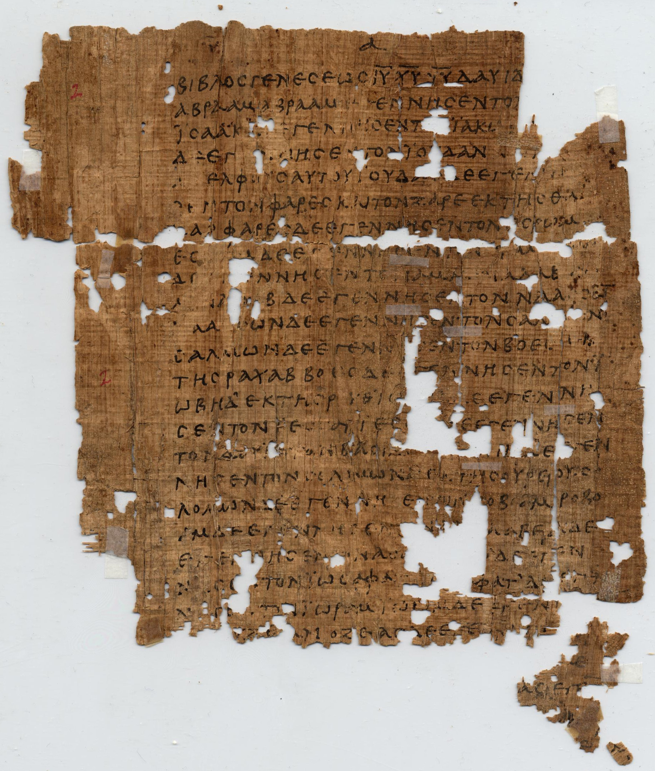
How To Become A Disciple Of Jesus Christ

Jesus’ Sermon on the Mount: Study 8
‘Obedience’
(Matthew 7:13 - 29)

[Jesus said,] “Not everyone who says to me, ‘Lord, Lord,’ will enter the kingdom of heaven,but only the one who does the will of my Father who is in heaven.”
(Matthew 7:21)

In 1 Corinthians 3 Paul teaches about the importance of Christian teachers, leaders, and workers making sure that they build the Church faithfully on the true foundation of Jesus Christ. In verses 10 – 15 he uses a parable about builders who use a range of materials that vary greatly in value and durability. He does so to illustrate and to warn that God will finally test the quality of each builder’s work. It is possible that Paul’s analogy is based on a similar parable told by Jesus at the conclusion of his Sermon On The Mount (Matthew 7:24 – 27). In Jesus’ example only two builders are in view -- one who built his house on a rock and another who built his house on the sand. When a great storm arose the house on the rock stood firm while the house on the sand collapsed. Jesus told this parable to describe the difference between those who build their lives upon his teaching and those who do not.

1. Read Matthew 7:13 – 14. In real terms, what are the wide and the narrow roads and why does one lead to life and the other to destruction?

2. Why do only a few take ‘the narrow road’ that leads to life? (Matthew 7:14)

3. Read Matthew 7:15. Here Jesus introduces his famous image of a wolf in sheep’s clothing. What is Jesus warning us about through this compelling image?

4. Read Matthew 7:16 – 20. While the wolf disguised in sheep’s clothing may not be easy to recongnise at first glance, Jesus points out that there is a noticeable difference between a grape vine and a thorn bush. Explain the meaning of Jesus’ statement, “A good tree cannot bear bad fruit, and a bad tree cannot bear good fruit... Thus, by their fruit you will recognize them.”

5. Read Matthew 7:28 – 29. In your experience, what is it about Jesus and his teaching that makes him standout from other teachers?

6. What does Jesus mean, “Every tree that doesn’t bear good fruit is cut down and thrown into the fire”? (Matthew 7:19)

7. Read Matthew 7:21 – 23. Why does Jesus say that on judgement day, not everyone who calls him ‘Lord’, or who claims to have done great things in his name, will enter his kingdom? Who will enter his kingdom and on what basis will they enter?

8. Read Matthew 7:24 – 27. Notice that both groups of people in this parable hear Jesus’ words; but only his true disciples do what he says. Therefore, what practical steps will you take to make sure that you become a ‘doer’ and not merely ‘hearer’ of Jesus’ instructions? Reflect back on Jesus’ Semon On The Mount. Think of one area of Jesus’ teaching that you need to work on more faithfully as his disciple.

