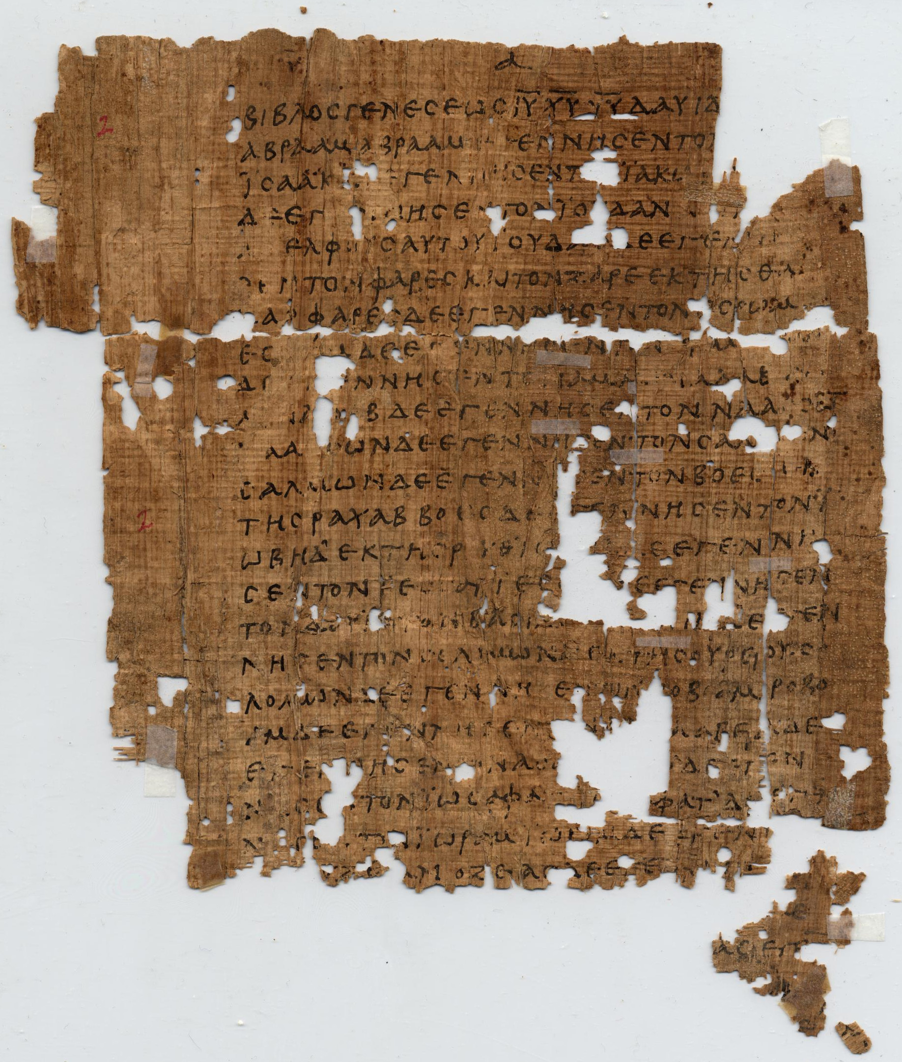
How To Become A Disciple Of Jesus Christ

Jesus’ Sermon on the Mount: Study 7
‘Judgment and Forgiveness’

[Jesus said,] “Do not judge, or you too will be judged. For in the same way you judge others, you will be judged, and with the measure you use, it will be measured to you.” (Matthew 7:1 – 2)

Matthew’s gospel contains a shocking parable about an unforgiving servant. Because this servant owed his master a very large sum of money, he was about to be imprisoned and lose everything he had. Therefore, he pleaded for mercy and his master completely cancelled his impossibly large debt. But having been shown this great act of mercy, this servant promptly tracked down a fellow servant who owed him a relatively small sum of money. When his fellow servant was unable to pay his debt, the unforgiving servant beat him and had him thrown into prison. When the master of the of the two servants heard about this he was furious and said to his unforgiving servant, “You wicked servant! I cancelled all that debt of yours because you begged me to. Shouldn’t you have had mercy on your fellow servant just as I had on you?” Then in anger his master had him thrown into prison until he paid back all that he owed. Jesus concluded this story saying, “This is how my heavenly Father will treat each of you unless you forgive your brother or sister from your heart”
(Matthew 18:21 – 35).

1. Read Matthew 5:38 – 47. How would you describe people’s normal attitude towards their enemies and those who have offended them? According to Jesus, what attitude and response should Christ’s disciples have towards our enemies?

2. Read Matthew 6:12 – 15. Now reflect back on Jesus’ parable of the unforgivng servant (Matthew 18:21 – 35). What principle and logic is behind Jesus’ words, “For if you forgive other people when they sin against you, your heavenly Father will also forgive you. But if you do not forgive others their sins, your Father will not forgive your sins”?

3. Read Matthew 7:1 – 5. Here Jesus gives his well-known analogy of a person with a plank in his eye earnestly trying to remove a splinter from another person’s eye. What is the meaning of this little parable?

4. Jesus said,“Do not judge, or you too will be judged. For in the same way you judge others, you will be judged, and with the measure you use, it will be measured to you”? However, in Luke 6:43 – 45 Jesus talks about the importance of judging or discerning between a good and evil person. What is the difference between these two types of judging, and why is the the judgment in Matthew 7:1 a sin?

5. In the same chapter where Jesus tells the parable of the unforgiving servant (Matthew 18) he also speaks about the importance of one beleiver confronting another believer who sins against him/her (18:15 - 17). What is the difference between confronting a fellow believer about his/her sin and judging that person?

6. Read Hebrews 12:1 – 3. Consider the price that Christ paid to forgive your sins. Then reflect on how you can become more Christ-like in the way that you relate with people who have sinned against or offended you.

