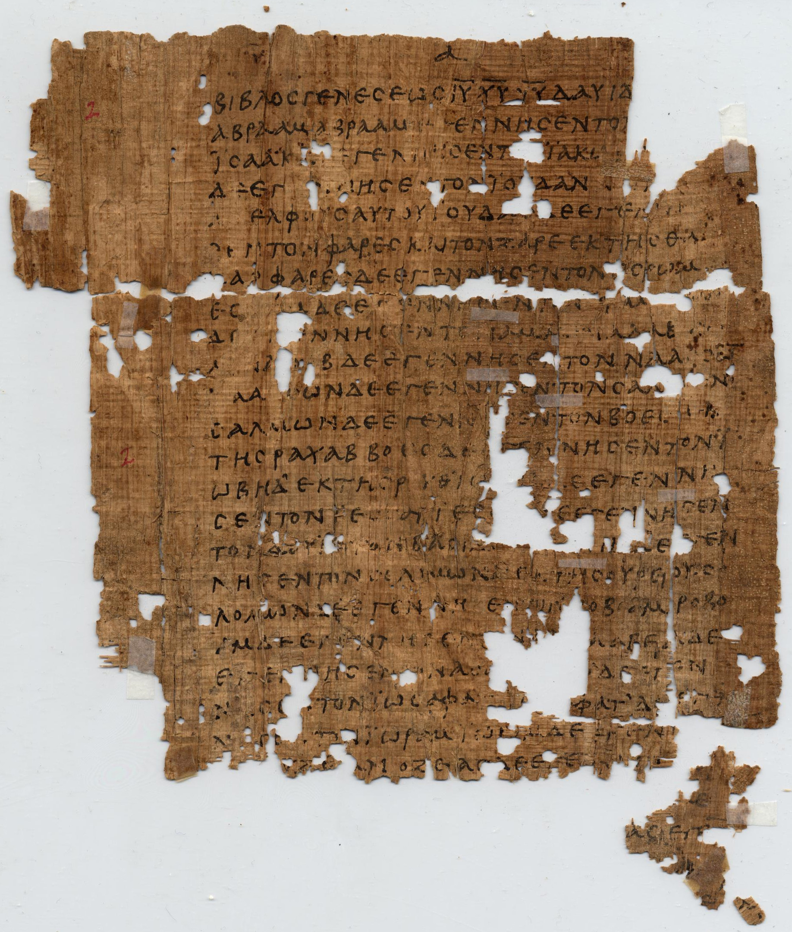
How To Become A Disciple Of Jesus Christ

Jesus’ Sermon on the Mount: Study 5
‘How should we pray?’
(Matthew 6:5 – 15; 7:7 - 11)

[Jesus said,] “And when you pray, do not keep on babbling like pagans, for they think they will be heard because of their many words. 8 Do not be like them, for your Father knows what you need before you ask him.” (Matthew 6:7 – 8)

Of all Jesus’ instructions in his Sermon On The Mount, perhaps the most well-known is the prayer that he taught his disciples (i.e. ‘The Lord’s Prayer’). There are two things that are particularly noteworthy about this prayer. First of all, it is brief. Jesus assures his disciples that God already knows our needs, even before we ask him. Therefore, Jesus gives us this clear and concise pattern of prayer so that we don’t feel the need to keep, ‘babbling on like the pagans, who think that they will be heard because of their many words’ (Matthew 6:7). Secondly, while this prayer is short in length, it is eternally broad in its scope – presenting the entire Christian worldview in just a few sentences. We should also take note of the fact that much of what Jesus lived and taught during his earthly ministry is summarized in this prayer. Finally, it’s amazing to think that for the past 2000 years this memorable little prayer has been recited again and again by Christians and churches around the world. So how should Jesus’ prayer shape our prayer lives today?

1. Read Matthew 6:5 – 15. Give some reasons why it’s important for disciples of Jesus to be taught how to pray.

2. What principles are behind Jesus’ instruction not to ‘babble on’ when we pray, or to think that God will hear us because of our many words? (Matthew 6:7 – 8)

3. Read Matthew 6:9 – 13 and reflect on the following lines from Jesus’ prayer. Write down at least one reason why each of these phrases is important:

“Our Father in heaven, hallowed (holy/honoured) be your name,

your kingdom come, your will be done, on earth as it is in heaven.

Give us today our daily bread.

And forgive us our debts (sins), as we also have forgiven or debtors (those who have sinned against us). [Also take note of Matthew 6:14 – 15].

And lead us not into temptation, but deliver us from the evil one.”
(i.e. Spare us from both the evil one and his temptations.)

4. Read Matthew 7:7 – 11. Given that Jesus has told us not to keep babbling on in our prayers, why does he also tell us to keep asking, seeking and knocking. What is the difference between persistent prayers and wordy prayers?

5. Think of one way that following Jesus’ instructions on prayer will change and improve your prayer life?

6. Conclude this study by praying The Lord’s Prayer. If you are in a group, you may use Jesus’ prayer to shape your community prayer time.

Or from evil; some late manuscripts one, / for yours is the kingdom and the power and the glory forever. Amen.

